Coding challange 4
Prasanna
2026-02-19
Table of Contents

Link to my GitHub
https://github.com/Prasanna-cb/PLPA6820/tree/main/Coding%20Challange%204

Question 1

Explain the following

  - The YMAL header is the top section an R Markdown file that tells R how to format and produce the output document.

  - Literate programming is the approach that use the codes, explanations, and results in a single document so that easily understand to a reader about the the logic, purpose, and outcome of the analysis.

Question 2

Reference
- Noel, Z.A., Roze, L.V., Breunig, M., Trail, F. 2022. Endophytic fungi as promising biocontrol agent to protect wheat from Fusarium graminearum head blight. Plant Disease. https://doi.org/10.1094/PDIS-06-21-1253-RE

Loading necessary libries
library(tidyverse)
library(ggpubr)
library(ggrepel)

Uploading the data to R
MycotoxinData=read.csv ("MycotoxinData.csv", na.strings = "na") #file path to GitHub repository

Createa a boxplot of DON by treatment and change the factor order level in X axis
MycotoxinData$Cultivar <- as.factor(MycotoxinData$Cultivar)
MycotoxinData$Treatment <- factor(MycotoxinData$Treatment,levels = c("NTC", "Fg", "Fg + 37", "Fg + 40", "Fg + 70"))
Fig1 <- ggplot(MycotoxinData, aes(x = Treatment, y = DON, fill = Cultivar)) +
geom_boxplot(position = position_dodge()) +
geom_point(position = position_jitterdodge(), alpha = 0.6) +
scale_fill_manual(values = c("orange", "blue")) +
xlab("") +
ylab("DON (ppm)") +
facet_wrap(~ Cultivar) +
theme_classic()
print(Fig1)
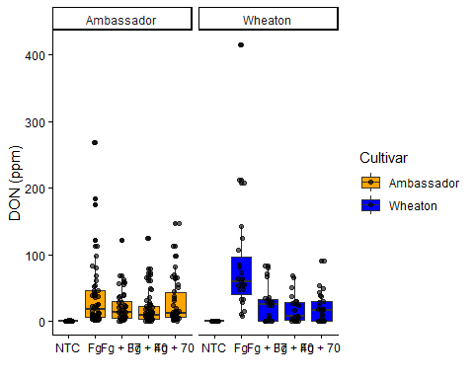

Change the y-variable to plot X15ADON
MycotoxinData$Cultivar <- as.factor(MycotoxinData$Cultivar)
MycotoxinData$Treatment <- factor(MycotoxinData$Treatment,levels = c("NTC", "Fg", "Fg + 37", "Fg + 40", "Fg + 70"))
Fig2 <- ggplot(MycotoxinData, aes(x = Treatment, y = X15ADON, fill = Cultivar)) +
geom_boxplot(position = position_dodge()) +
geom_point(position = position_jitterdodge(), alpha = 0.6) +
scale_fill_manual(values = c("orange", "blue")) +
xlab("") +
ylab("X15ADON") +
facet_wrap(~ Cultivar) +
theme_classic()
print(Fig2)
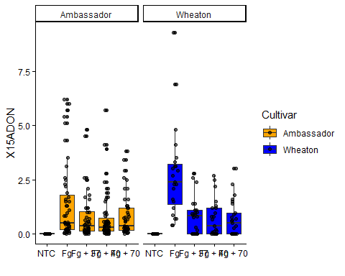

Change the y-variable to plot MassperSeed_mg
MycotoxinData$Cultivar <- as.factor(MycotoxinData$Cultivar)
MycotoxinData$Treatment <- factor(MycotoxinData$Treatment,levels = c("NTC", "Fg", "Fg + 37", "Fg + 40", "Fg + 70"))
Fig3 <- ggplot(MycotoxinData, aes(x = Treatment, y = MassperSeed_mg, fill = Cultivar)) +
geom_boxplot(position = position_dodge()) +
geom_point(position = position_jitterdodge(), alpha = 0.6) +
scale_fill_manual(values = c("orange", "blue")) +
xlab("") +
ylab("MassperSeed_mg") +
facet_wrap(~ Cultivar) +
theme_classic()
print(Fig3)
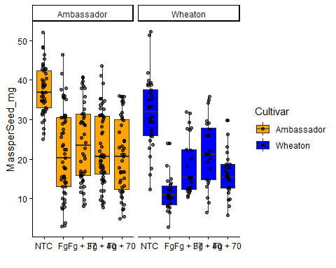

Use ggarrange function to combine all three figures
figure_combined <- ggarrange(
Fig1,
Fig2,
Fig3,
labels = "auto",
nrow = 1,
ncol = 3,
common.legend = TRUE,
legend = "top")
print(figure_combined)
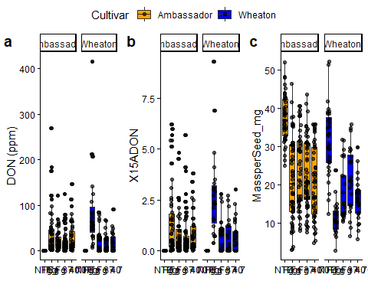

Use geom_pwc() to add t.test and pairwise comparisons to the above three plots
Fig1a <- Fig1 +
geom_pwc(aes(group = Treatment), method = "t_test", label = "p.adj.format")
print(Fig1a)
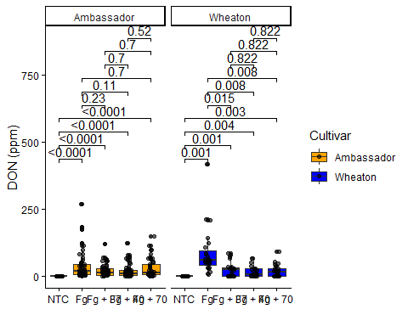
Fig2a <- Fig2 +
geom_pwc(aes(group = Treatment), method = "t_test", label = "p.adj.format")
print(Fig2a)
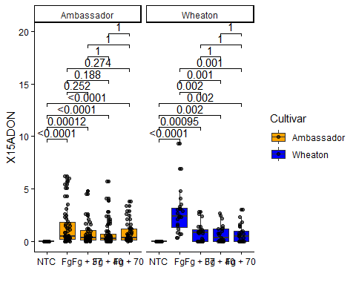
Fig3a <- Fig3 +
geom_pwc(aes(group = Treatment), method = "t_test", label = "p.adj.format")
print(Fig3a)
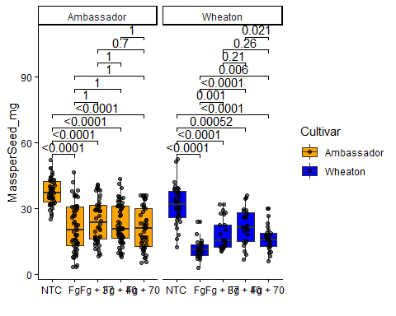

Integration of pairwise comparison results into a single plot
figure_combined_final <- ggarrange(
Fig1a,
Fig2a,
Fig3a,
labels = "auto",
nrow = 1,
ncol = 3,
common.legend = TRUE,
legend = "top")
print(figure_combined_final)
